Bridging the Health Gap
Holding conversations about health

The aim of this workshop is to support staff and volunteers working in the homelessness sector to build confidence in holding conversations about health and to find out more about available resources. This plan accompanies the PowerPoint slides.

Key messages
The key messages of the workshop are:
- People experiencing homelessness face significant healthcare challenges.
- People experiencing homelessness face significant barriers to accessing healthcare services.
- Workers in the homelessness sector have existing skills and opportunities to talk to people around their healthcare needs.

Instructions for facilitators
The following plan lays out the different parts of the workshop with suggested timings. The workshop should take 45 minutes – 1 hour depending on the size of the group.

- Familiarise yourself with the plan before running the workshop.
- Ask questions to encourage discussion.
- Keep an eye on the time. The exact timings may vary but you will need to keep roughly to the agenda in order to finish on time.
- PowerPoint instructions:
  - When you open the PowerPoint slides, be sure to clear ‘enable content’ so that you can play the films.
  - You will need an internet connection.
  - It is also a good idea to check the sound is loud enough before starting.
  - The films are not cut into the suggested section, but are the whole films. You will need to manually start and stop the films at the suggested time points.

Timing | Section | Instructions
0:00 to 5:00  5 mins | Introductions | Welcome to the meeting.  Introduction to the topic & myth busters.  Slides 1-4
5:00 – 10:00  5 mins to think and write.  5 mins discussion. | Exercise | - Think about a time when you’ve had a really positive health-related conversation.  - Let people know that you are not asking them to share anything traumatic or challenging & that they do not have to share with the group if they do not feel comfortable.  - Think about what made it a positive experience.  - Provide examples as prompts: the person listened, they were thorough, they respected me, they gave clear information.  Slides 5-6
10:00-15:00  5 mins | Group Discussion 1 | - Group discussion.  - What does a conversation about health look like? What questions would you be asking?  - Examples for prompting: Are you registered with a GP? Are you experiencing barriers to accessing health/dental care? What help do you need to overcome these barriers? What resources are available locally?  - Discuss what you are trying to achieve by having these conversations & how they might have a positive impact on that individual’s health outcomes.  Slide 7
15:00 – 20:00  5 mins | Film Clip 1 | - Introduce Less film.  - Watch from 25 seconds to 1 minute 55 seconds.  - STOP film.  Slides 8-9
20:00 - 25:00  5 mins | Group Discussion 2  Barriers to accessing healthcare services | - Group discussion  - Reflections on film  - What are some of the barriers faced by people experiencing homelessness?  - Any other thoughts?  - This is a list of suggested barriers to healthcare.  - There may be others and you may have different suggestions from your own discussion.  Slides 10 & 11
25:00 – 30:00  5 mins | Film Clip 2 | - Introduce Clarissa film.  - Make it clear that this is NOT being presented as good practice.  - Watch Clarissa Clip  - Minutes 3:40-6:20  - STOP film.  Slides 12-14
30:00 – 35:00  5 mins | Group Discussion 3 | - Discussion based on film and experience.  - What are your reflections?  - What could the outreach workers have done differently?  - Did anything go well?  - What makes a positive health conversation?  Slide 15
35:00-40:00  5 mins | What makes a positive health interaction | - This is a list of suggestions.  - There may be others and you may have different suggestions from your own discussion.  Slide 16
40:00 – 50:00  10 mins | Small group discussion | - Put into groups of 3-4, or 2-3 if in smaller group. If you are only a small group to start with, discuss all together.  - What are some of the barriers that you face as workers to having better health conversations?  - E.g., confidence around health, time, training etc.  - Share with main group after 10 mins and discuss which resources people may need to support them.  Slide 17
50:00-55:00  5 mins | Feedback to main group | - Come back together as a whole group.  - Discuss which resources people may need to support them in having health conversations.  - You may wish to avoid going around each group individually and asking for their notes as this can be time consuming.  - Write a list and create actions.  Slide 17
55:00 – 60:00  5 mins | Summary and link to resources | - Summarise meeting.  - Write down any actions for the group.  - Share resources from the Bridging the Health Gap Project  - Thank the group for their time.  Slide 18

What We Do

Homeless Link is the national membership charity for frontline homelessness services. We work to improve services through research, guidance and learning, and campaign for policy change that will ensure everyone has a place to call home and the support they need to keep it.

Homeless Link
Minories House
2-5 Minories
London
EC3N 1BJ

www.homeless.org.uk
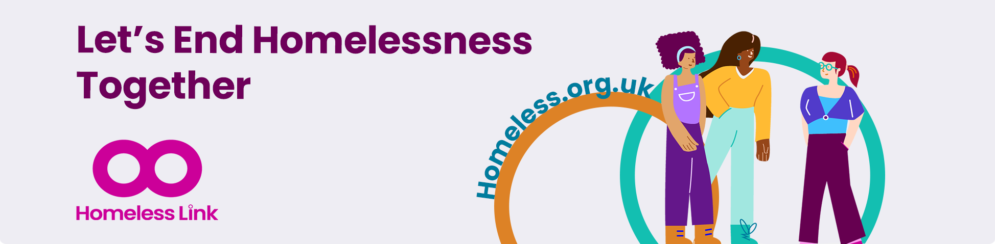
@HomelessLink

